 | IQVIATM Work Instruction  Global Regulatory Affairs – US Maintenance Submissions
Document Number and Revision:
CS_WI_RA0280 Revision 4
Document Owner:  Anja De Pauw | Author(s):  Maggie Rahman

PURPOSE

  - To describe the responsibilities for Global Regulatory Affairs (GRA) in the lifecycle maintenance activities associated with United States (US) Maintenance Submissions submitted to the US Food and Drug Administration (FDA).

SCOPE

  - This work instruction (WI) applies to all GRA staff involved in the preparation, review and approval of amendments, responses, annual reports, transfer of sponsorship or any other submission submitted to the US FDA on behalf of the client.

ROLES AND RESPONSIBILITIES
The following roles perform tasks described within this WI:

Role | Sections
Regulatory Team Member/eCTD Lead (RTM) | 6.1, 6.2, 6.3, 6.4
Regulatory Publisher (RP) | 6.2, 6.3, 6.4
Regulatory Project Manager (RPM) | 6.3, 6.4

DEFINITIONS
US maintenance submissions: any submission that needs to be provided to the US FDA to keep an active application such as, but not limited to, an Investigational New Drug (IND) Application, New Drug Application (NDA), Biologics License Application (BLA), Abbreviated New Drug Application (ANDA) up to date and current or to report any necessary information to the US FDA for these applications.
Examples of US maintenance submissions include, but are not limited to: IND Protocol Amendments:
- New Protocol; Change in Protocol
- New or Updated Principle Investigator(s)
Labeling, Quality, Efficacy, and Safety Information Amendments Requests for:
- Meeting (meeting requests and meeting information packages)
- Proprietary Name Review
- Special Protocol Assessment

Page 1 of 6

Periodic Safety Reports
Request for Reactivation of an inactive IND Response to Clinical Hold
Development Safety Update Report (DSUR) Annual Report
Response to FDA Request for Information General Correspondence
Updates to Investigator’s Brochure
Risk Evaluation and Mitigation Strategies (REMS) Supplements Post-marketing Requirements or Commitments
Other – items that don’t fall into the above categories

MATERIAL AND EQUIPMENT
Not Applicable

PROCEDURE

  - US Submission Maintenance Notification

No: | Who: | Step: | When:
6.1.1 | RTM | Obtains notification from the client or internal IQVIA team that a US maintenance submission needs to be submitted to the US FDA. | At notification
6.1.2 | RTM | - Requests that all prior sequences be provided, if the application is being transferred from the client or another Contract Research Organisation (CRO).  - Requests a bulk import of the eCTD sequences and verify successful importation into the eCTD tool by RP (refer to CS_WI_RA0292 Publishing - Producing Clinical and Submission Publishing Deliverables), if it concerns an electronic common technical document (eCTD). | At notification

  - US Submission Maintenance Setup and Tracking

No: | Who: | Step: | When:
6.2.1 | RTM | Enters the US maintenance submission in the submissions calendar and current GRA tracking/metrics tool capturing needed information in available fields. | At notification and conclusion of submission to FDA
6.2.2 | RTM | Creates (if new project) and maintains the project instructions (refer to CS_TP_PL0073 Project Instruction). | Ongoing during project
6.2.3 | RTM | If new project, requests a new file structure setup from RP. | At notification

  - US Submission Maintenance Submission Preparation

No: | Who: | Step: | When:
6.3.1 | RTM | - Confirms receipt to the IQVIA Regulatory Lead of content-final documents and provides a projected submission date. Either confirms or re-negotiates the submission date if a specific submission date has been requested by the client.  - Creates and controls planned submission per the submissions calendar. | Upon receipt of content-final documents for the maintenance submission
6.3.2 | RTM | Prepares the relevant FDA Forms (found on the FDA website) and cover letter as per project instructions. | No later than 48 hours before submittal due date
6.3.3 | RTM | If needed, completes the appropriate US Submission Maintenance tracker; prepares a pre-publish request and provides it to the RP via e-mail (refer to CS_WI_RA0292 Publishing - Producing Clinical and Submission Publishing Deliverables). | Upon receipt of content-final documents
6.3.4 | RTM | Processes the US maintenance submission (refer to CS_WI_RA0292 Publishing - Producing Clinical and Submission Publishing Deliverables). | As per the publishing timeline
6.3.5 | RP | Requests the RTM or designee to perform a management quality control (QC) of the final submission (refer to CS_WI_RA0292 Publishing - Producing Clinical and Submission Publishing Deliverables). | Upon completion of publishing tasks
6.3.6 | RTM | Performs management QC of the final submission and documents the QC using CS_TP_RA0289 Publishing - Management Publishing Quality Control Checklist. | Upon receipt of a QC request
6.3.7 | RTM | Confirms any changes that were made to the submission by the RP and signs CS_TP_RA0289, Publishing - Management Publishing QC Checklist, to authorize release for client review or submittal to FDA as defined in the project instructions. | After changes have been implemented
6.3.8 | RP | Runs final validation in eCTD tool and releases to the RPM for client approval, if required per project instructions. | As soon as possible after step 6.3.7
6.3.9 | RPM | If required, provides the submission per the project instructions to the client for their review and approval to submit. Repeat steps 6.3.4 through 6.3.9 if any changes are requested by the client. | As soon as possible after step 6.3.8
6.3.10 | RTM | If physical copies are required, requests the copies from the RP designee to prepare and ship according to the established timeline. | As needed to factor time needed to ensure on time delivery to FDA

  - US Maintenance Submission Delivery

No: | Who: | Step: | When:
6.4.1 | RTM | Submits the US maintenance eCTD submission through the FDA Electronic Submissions Gateway (ESG). | Upon receipt of approval to submit to the FDA
6.4.2 | RTM | Provides the final submission and ESG acknowledgements to the RPM per the project instructions. | Upon receipt of approval to submit to the FDA
6.4.3 | RPM | Provides the final submission and ESG acknowledgments to the client. | Once received from RTM
6.4.4 | RTM or RP | Updates publishing metrics in the GRA tracking/metrics tool.  Note: All documentation (QC checklists, submission trackers, etc.) for the US maintenance submissions are stored on the IQVIA file server per Electronic Document File Management. | Upon receipt of approval to submit to the FDA

- SUPPORTING DOCUMENTATION

DOCUMENT NUMBER | TITLE
ESOP References
7.1 CS_WI_RA0292 | Publishing - Producing Clinical and Submission Publishing Deliverables
7.2 CS_TP_RA0289 | Publishing - Management Publishing Quality Control Checklist
7.3 CS_TP_PL0073 | Project Instruction
External References
7.4 Title 21 | Code of Federal Regulations (21 CFR)
7.5 ICH M2 | Electronic Common Technical Document (eCTD) Specification
7.6 ICH M4 | The Common Technical Document
7.7 www.fda.gov | FDA Website

- SUPERSEDES

DOCUMENT NUMBER | TITLE | REVISION NUMBER
8.1 CS_WI_RA0280 | Global Regulatory Affairs - US Maintenance Submissions | 3

- MODIFICATION FROM PREVIOUS REVISION

CHANGE | SECTION REFERENCE | JUSTIFICATION
- Renamed Roles | 3.0 and 6.0 | For consistency across GRA-SOPs

- APPENDICES

  - Appendix A: US Maintenance Submissions Process Flow

 | Document Title:  Global Regulatory Affairs - US Maintenance Submissions
Document Number and Revision:
CS_WI_RA0280 Revision 4
Appendix A: US Maintenance Submissions Process Flow
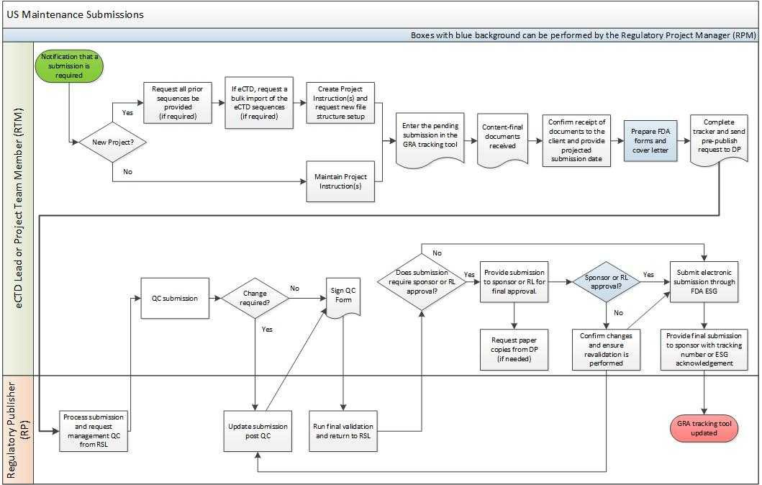

Page 6 of 6
Copyright © 2015, 2017, 2019, 2021 IQVIA. All rights reserved. The contents of this document are confidential and proprietary to Quintiles IMS Holdings, Inc. and its subsidiaries. Unauthorized use, disclosure or reproduction is strictly prohibited.

UNCONTROLLED COPY CS_WI_RA0280 Revision 4 - EFFECTIVE on 01-Nov-2021

UserName: Galea, Claudine (q769301) Title:
Date: Monday, 04 October 2021, 05:07 AM Eastern Time Meaning: Signing this Document Indicates My Approval
================================================

UserName: Lobo, Zena (q833472) Title:
Date: Monday, 04 October 2021, 05:08 AM Eastern Time Meaning: Signing this Document Indicates My Approval
================================================

UserName: Lewicky, Tamara (q730348) Title:
Date: Monday, 04 October 2021, 05:49 AM Eastern Time Meaning: Signing this Document Indicates My Approval
================================================

UserName: Kemp, Jaco (q608126) Title:
Date: Monday, 04 October 2021, 11:45 AM Eastern Time Meaning: Signing this Document Indicates My Approval
================================================

UserName: Rahman, Maggie (q1033930) Title:
Date: Monday, 04 October 2021, 11:47 AM Eastern Time Meaning: Signing this Document Indicates My Approval
================================================

UserName: Corley, Helen (q730385) Title:
Date: Monday, 04 October 2021, 12:38 PM Eastern Time Meaning: Signing this Document Indicates My Approval
================================================

UserName: Glizer, Veronica (q735279) Title:
Date: Wednesday, 06 October 2021, 12:57 PM Eastern Time Meaning: Signing this Document Indicates My Approval
================================================

